**Practical – 3**

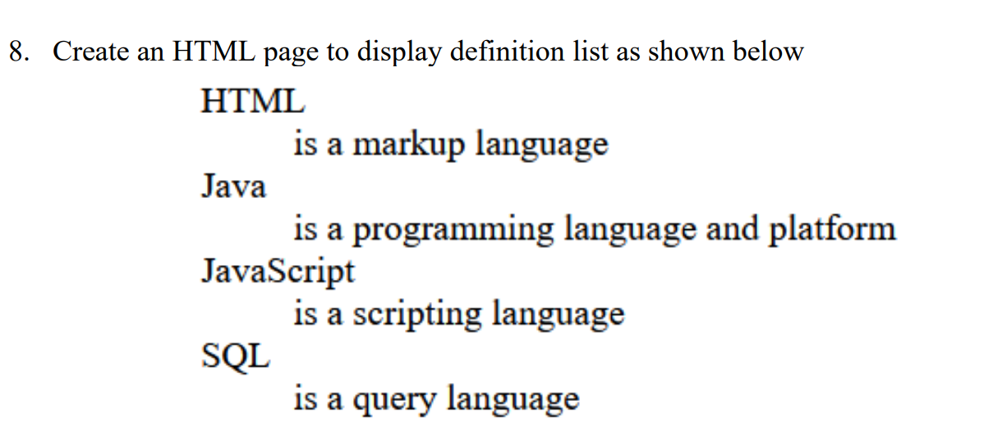

**HTML Code**

<!DOCTYPE html>

<html lang="en">

<head>

<meta charset="UTF-8">

<meta name="viewport" content="width=device-width, initial-scale=1.0">

<title>Rowspan & Colspan </title>

</head>

<body>

<dl>

<dt>HTML</dt>

<dd>is a markup language</dd>

<dt>Java</dt>

<dd>is a programming language and platform</dd>

<dt>Javascript</dt>

<dd>is a scripting language</dd>

<dt>Sql</dt>

<dd>is a query language</dd>

</dl></body>

</html>

**Output**

